Smartly: Ad Campaign DataFlow

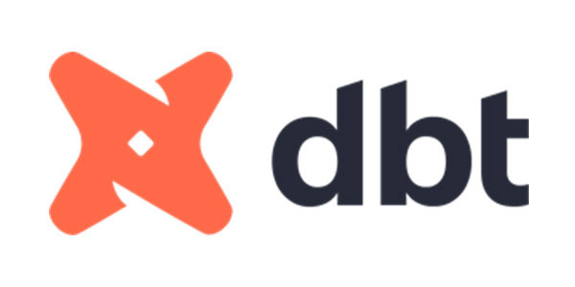


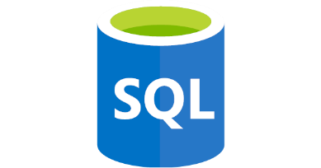
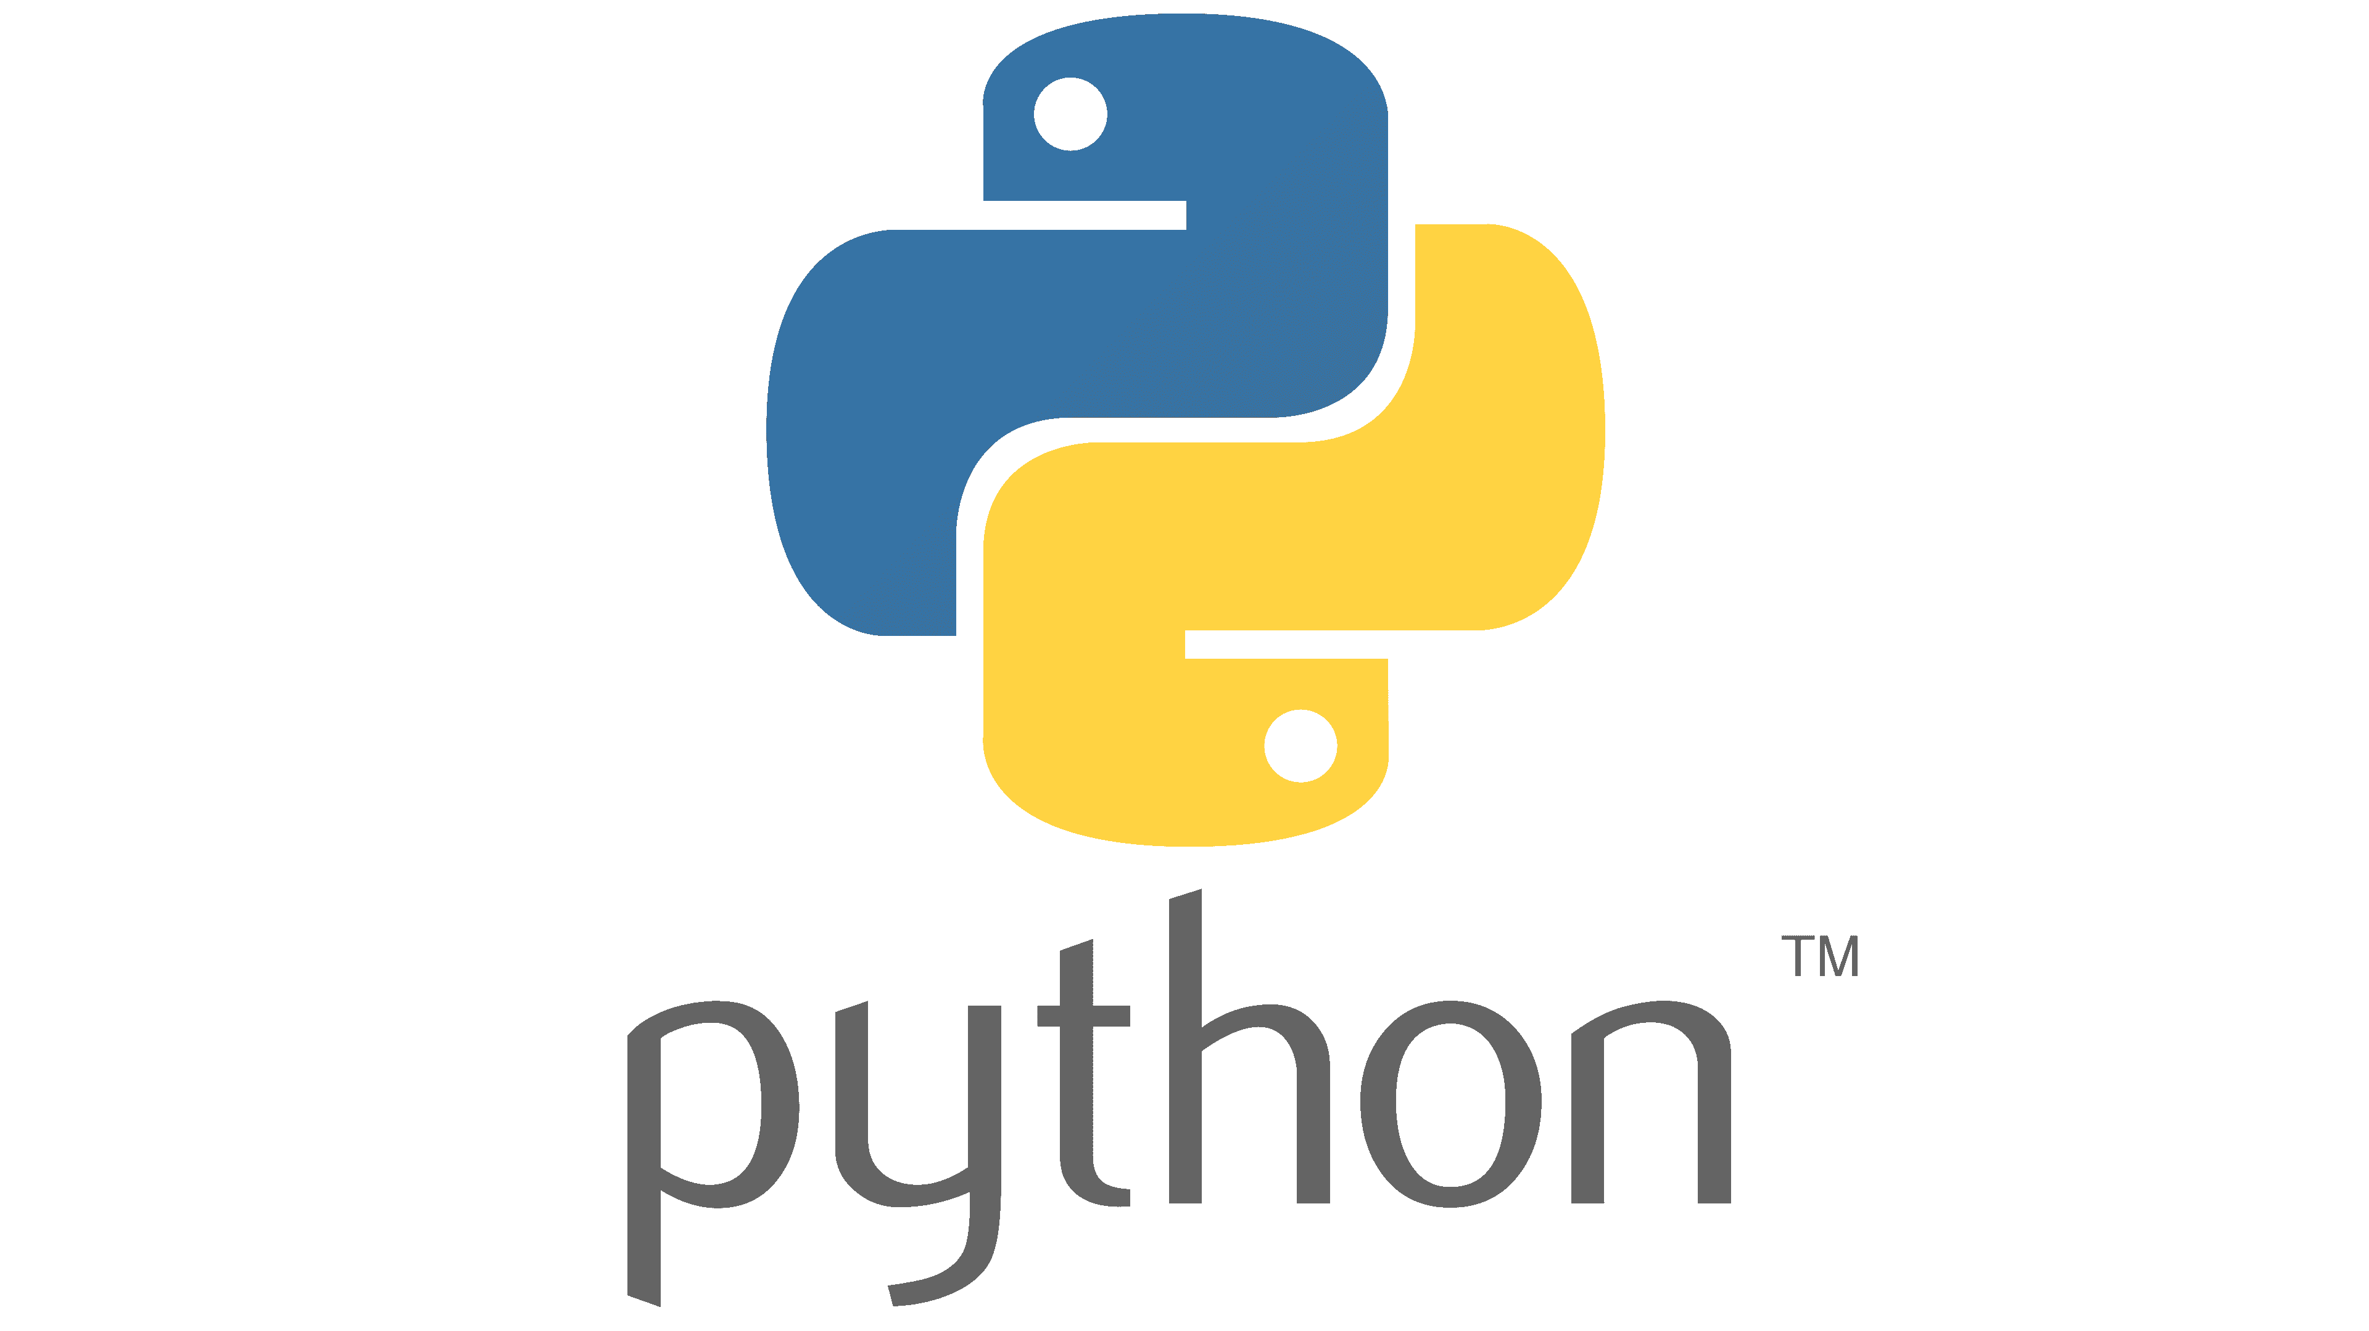

Name: Nuwan Keshara Galappaththi
Email: nuwankeshara12@gmail.com
Phone: (+358) 41 740 3217
LinkedIn: https://www.linkedin.com/in/nuwan-keshara/
GitHub: https://github.com/NuwanKeshara

Contents
1) Project Title 3
2) Objectives / Problem Statement 3
3) Tech Stack 4
4) Architecture / System Design 5
Workflow Steps: 5
5) Implementation Steps 6
1. Data Ingestion (Python) 6
2. Data Quality Checks (Python) 6
3. Transformation and Modeling (DBT) 6
4. Testing (DBT) 7
5. Orchestration (Airflow) 7
6) Code and Results 8
7) Summary 16

Project Title

- SMARTLY : Ad Campaign DataFlow

Objectives / Problem Statement

- A marketing analytics company runs multiple advertising campaigns on Facebook. Raw campaign performance data is collected as CSV exports that include metrics such as impressions, clicks, spend and conversions.

- Dataset - https://www.kaggle.com/datasets/loveall/clicks-conversion-tracking

- The problem:
- Raw CSVs are inconsistent, not cleaned and don’t provide analytical insights directly.

- Goal:
- Build a production-grade data pipeline that:
  - Ingests raw Facebook Ad campaign CSVs automatically.
  - Cleans, validates, and loads data into a centralized data warehouse (GCP BigQuery).
  - Applies modular data transformations and testing with DBT.
  - Automates end-to-end orchestration using Apache Airflow (Docker-based).
  - Produces analytics-ready models and materialized views for business reporting

Tech Stack

Layer | Tool | Purpose
Data Source | CSV File | Raw Facebook ad campaign data
Ingestion & Cleaning | Python (Pandas, SQLAlchemy, GCP SDK) | Extracts CSV → cleans → loads to BigQuery
Storage / Warehouse | GCP BigQuery (previously PostgreSQL) | Centralized data warehouse
Transformation & Modeling | dbt (Data Build Tool) | Data transformations, modeling and testing
Orchestration | Apache Airflow (Docker) | Automates pipeline execution (daily at 12 AM)
Version Control | Git / GitHub | Code management and collaboration
Environment Management | Python dotenv | Secure configuration and secret management

Architecture / System Design

- Pipeline Flow
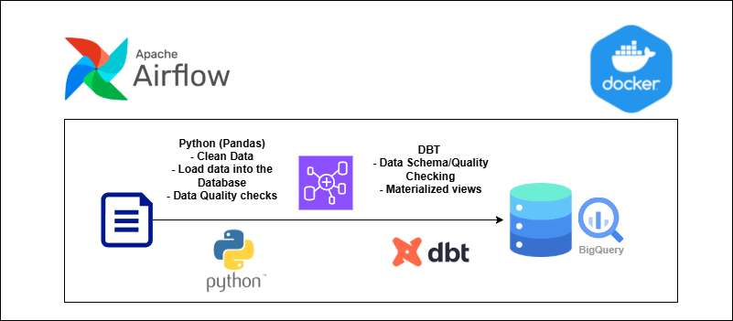

CSV Source >> Data Load (Python) >> Data Quality Check >> DBT Modeling >> DBT Tests >> Data Load to Model Table >> DBT Modeling Metrics >> DBT Tests

Workflow Steps:
- Airflow DAG orchestrates all pipeline tasks in Dockerized environment.
- Python scripts handle ingestion, validation and data loading into BigQuery.
- dbt models transform, clean and aggregate data into analytics ready tables.
- dbt tests ensure data integrity and quality.
- Final materialized views support reporting dashboards or BI tools.

Implementation Steps

Data Ingestion (Python)
- Read raw CSVs with Pandas.
- Standardize column names and handle nulls.
- Validate schema and filter out invalid records (ex: negative spend or clicks).
- Load cleaned data into BigQuery from raw_ad_logs.csv

Data Quality Checks (Python)
- Custom Python script run_quality_checks_staging_table.py:
  - Checks for nulls
  - Validates non-negative numeric columns
  - Detects duplicates
  - Logs all results to logs/ run_quality_checks_staging_table.log

Transformation and Modeling (DBT)
- DBT Models
  - Staging
    - daily_ad_logs_view.sql (staging model)
Cleans and standardizes raw data (lowercases gender, fills nulls, etc.)
    - campaign_daily_metrics_view.sql
Aggregate data and group by company_id
  - Data_model
    - campaign_metrics_view.sql
aggregate all the metrics for whole the period

- Data Model Table
  - Aggregate columns and derived new values
    - Click_rate = clicks / impressions
    - Spent_rate = spend / impressions
    - Conversion_rate = conversions / clicks

Testing (DBT)
- schema.yml defines data quality tests:
  - not_null, unique, accepted_values, dbt_utils.expression_is_true
- Custom test macros for non_negative and logical data validation
- Tests run automatically with:
  - dbt test with Airflow automation

Orchestration (Airflow)

- DAG Schedule: Daily at 12:00 AM

Execution order:
- load_to_bigquery.py - Ingests CSVs to BigQuery.
- run_quality_checks_staging_table.py - Validates staging layer.
- dbt models:
  - daily_ad_logs_view.sql - Build staging materialized views.
  - Campaign_daily_metrics_view.sql – Build metrics in staging materialized views

- dbt tests - Validate staging layer.
- staging_to_datamodel.py - Move staging to model tables.
- dbt model:
  - campaign_daily_metrics.sql - Final analytics view.
- dbt tests - Validate data model layer

Code and Results

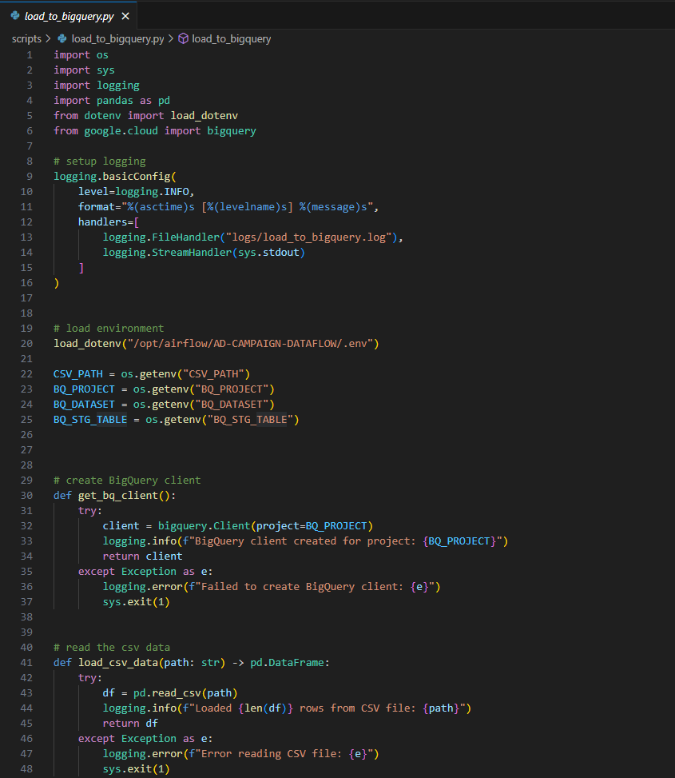
- load_to_bigquery.py – Load data into GCP BigQuery database

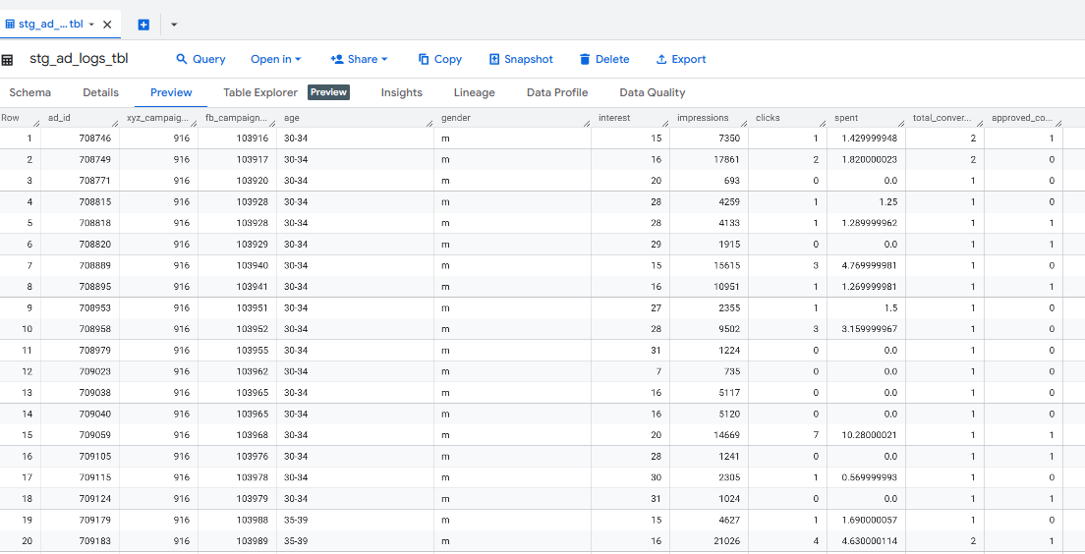
- Result:

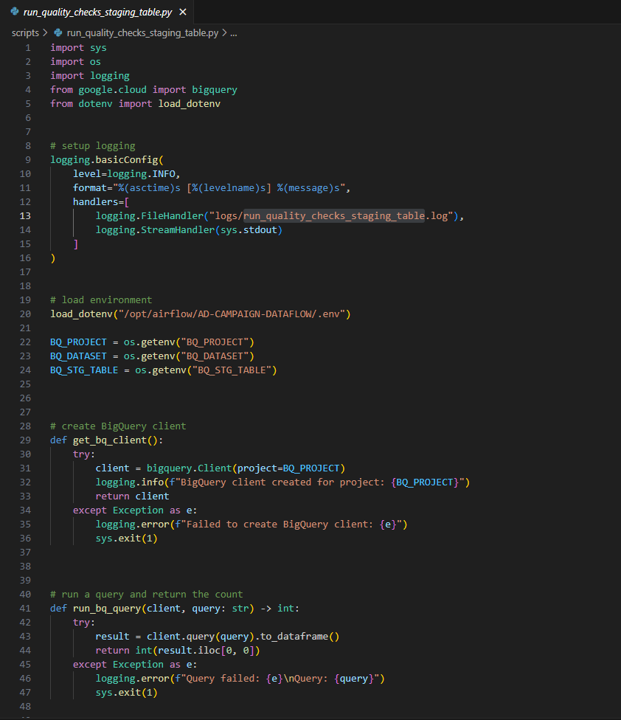
- run_quality_checks_staaging_table.py - Data Quality Cheks

- Results:
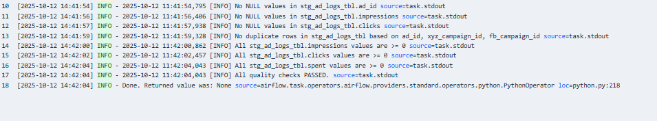

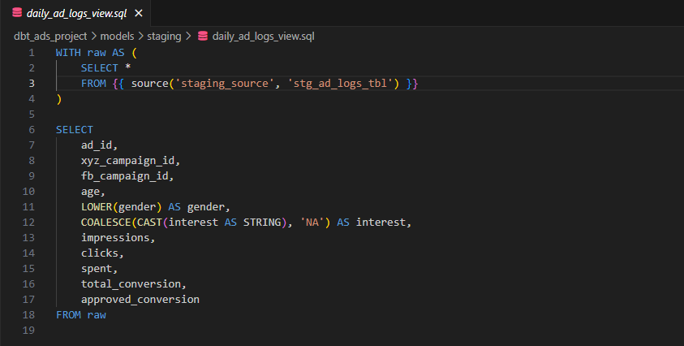
- daily_ad_logs.sql – create materialized view on dataset

- Results:
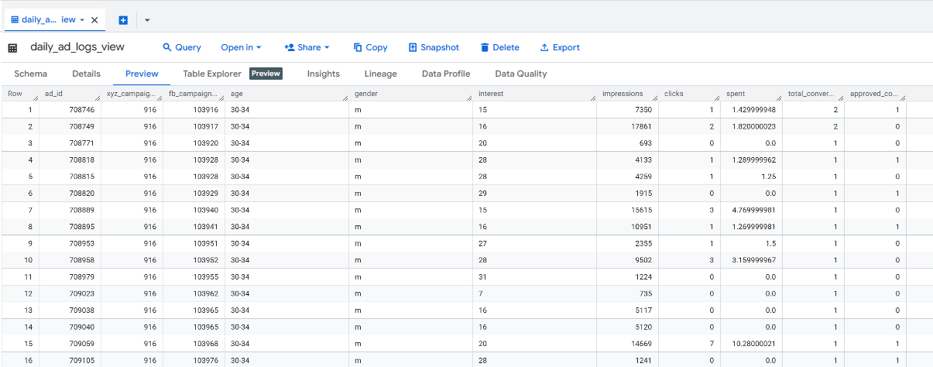

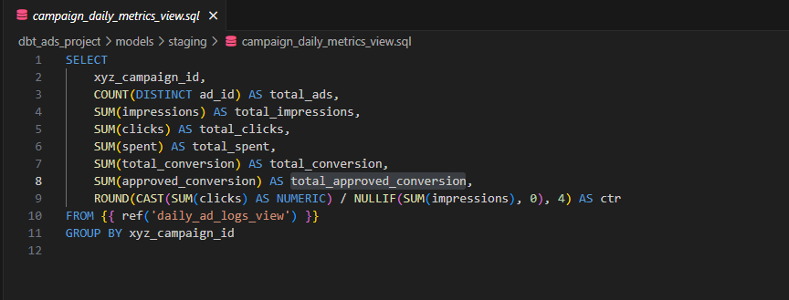
- campaign_daily_metrics_view.sql – aggregate data and group by company id materialized view

- Results:
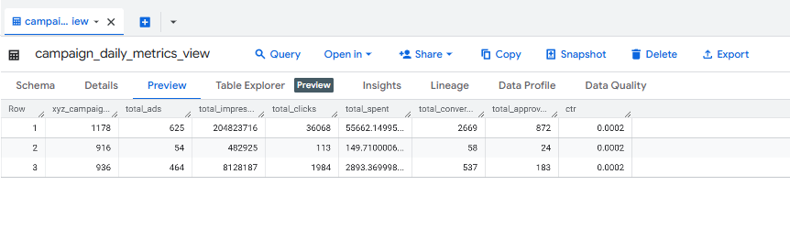

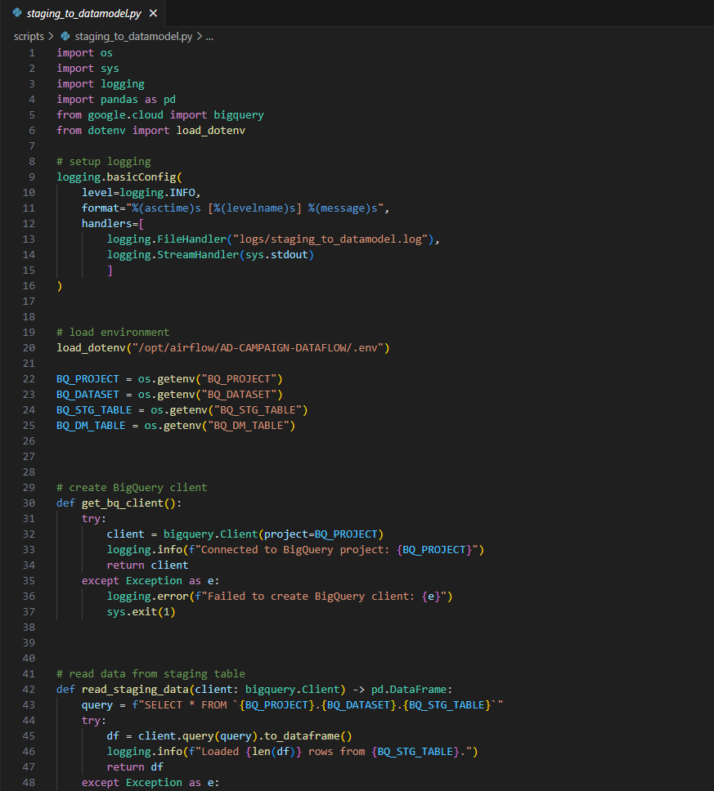
- Staging_to_datamodel.py – load data from staging to data model table

- Result:
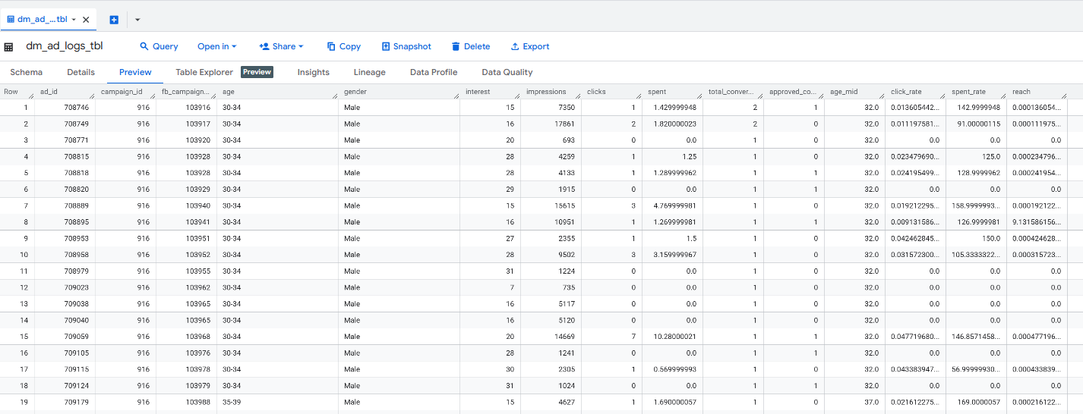

- campaign_metrics_view.sql – aggregate data and group by company id materialized view for the whole data
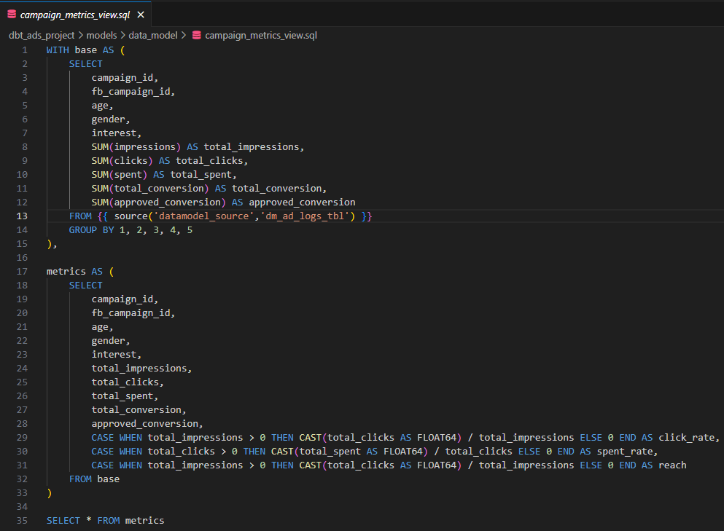
- Results:
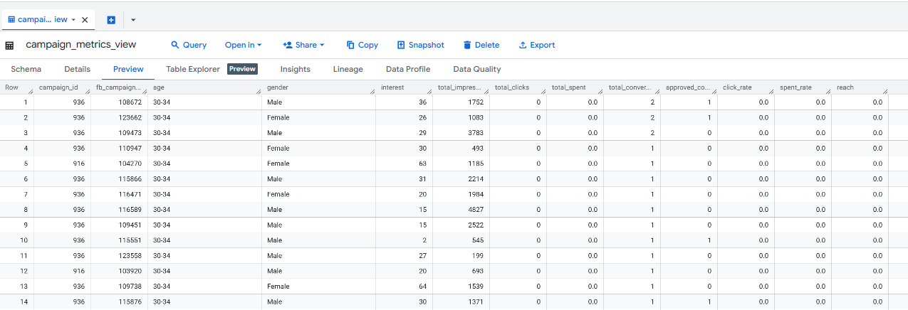

- Airflow Orchestration DAG
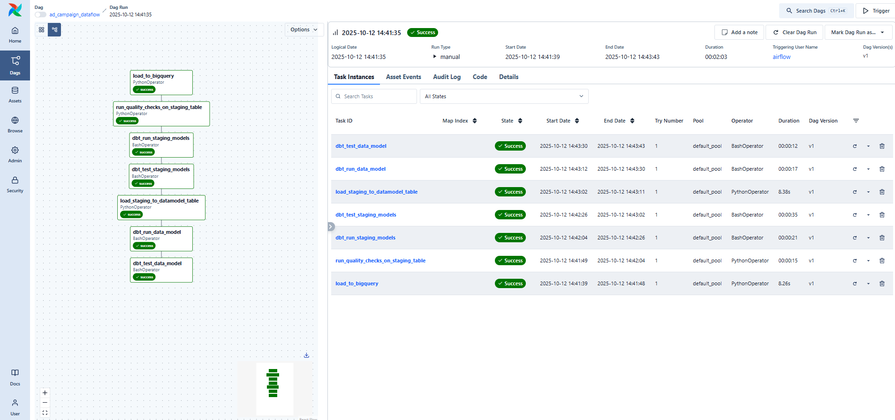

- Full Code for the project can be found on GitHub - https://github.com/NuwanKeshara/Ad-Campaign-Dataflow

Summary

What started as a local ETL prototype (PostgreSQL + manual execution) has evolved into a scalable, automated, cloud-based data pipeline with,

- GCP BigQuery for analytical warehousing
- dbt for modular transformations and testing
- Dockerized Airflow for orchestration
- Automated daily scheduling.

This setup demonstrates a modern ELT architecture ready for analytics and can easily extend to other data sources and ad platforms.

